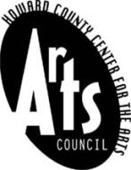

Howard County Arts Council

Visual and Performing Arts Summer Camp

CALL FOR VOLUNTEERS

Looking for a fun, CREATIVE way to earn service learning hours?

Apply to work with the Howard County Arts Council’s

Visual and Performing Arts Summer Camp 2018!

Summer Camp Volunteers are crucial to the success of our
Visual and Performing Arts Summer Camp- which is why we need you!
Volunteers serve as classroom aides to ensure a positive and safe camp
experience for all during our week-long arts camps.

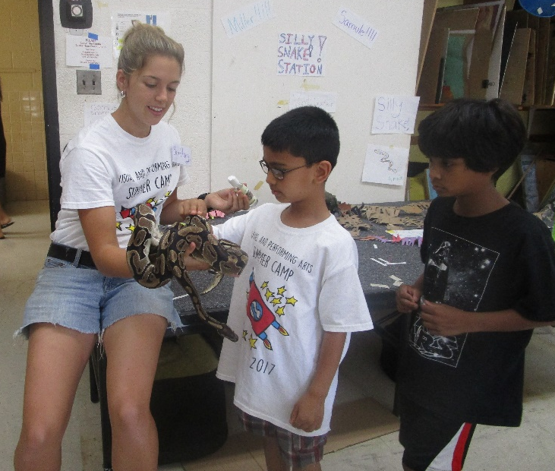
The Drawing Zoo
-HCAC Summer
Camp 2017

Visual and Performing Arts camps are offered to children grades K-7 in one week sessions from June 25- August 24.
Camp Volunteers
  - Must be age 15 by September 1, 2018
  - Must commit to at least one full ½ day session, Mon-Fri, 8:45am-12pm OR
12:30pm - 3:45pm
- May may volunteer any of the weeks (Sessions 1-9) that s/he is available and is scheduled
  - While position is unpaid, service learning hours may be earned

For more information and to apply, visit the Howard County Arts Council website at www.hocoarts.org or call the Howard County Arts Council at 410-313-2787.

